Practical No:01

**Aim:** Linux Installation

a) Install your choice of Linux distribution e.g. Ubuntu, Fedora, Debian.

Installing Zorin Operating System:

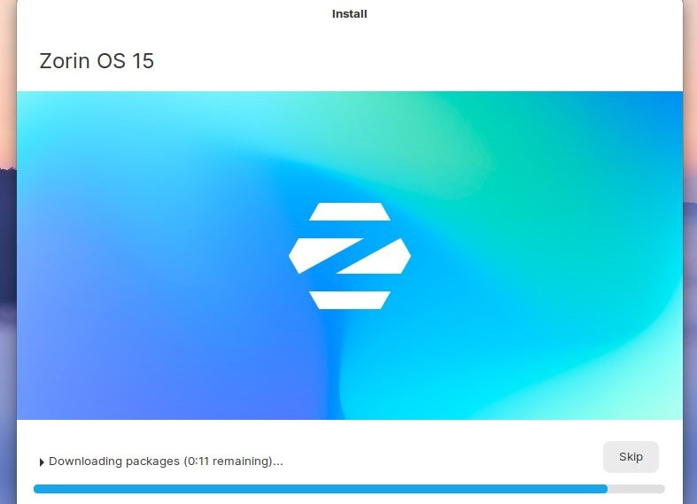

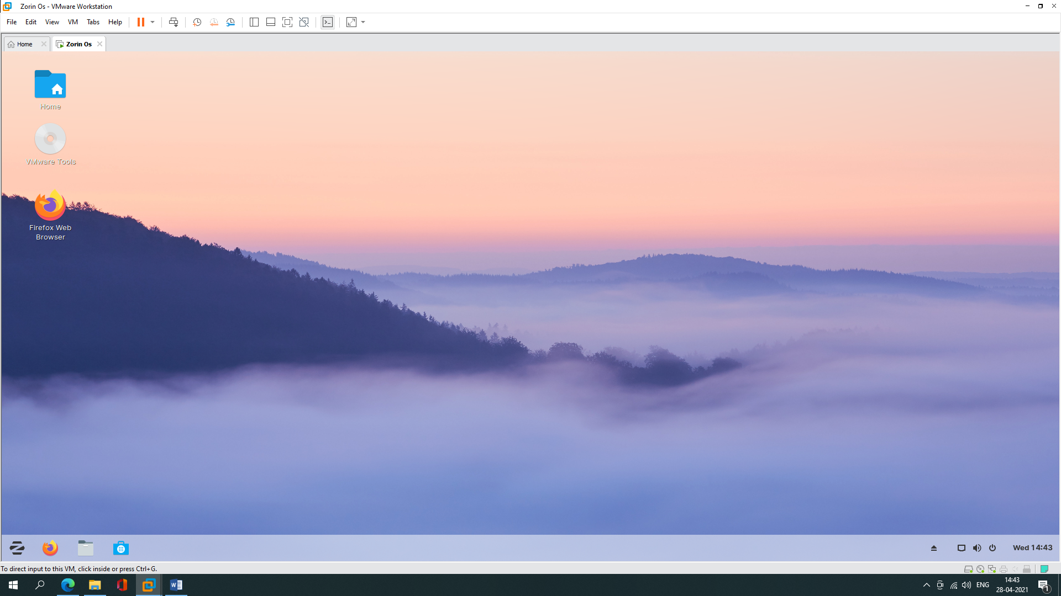

b) Customize desktop environment by changing different default options like changing default background, themes.

**Changing background**

**Go to settings, click on ‘appearance’ and select the option wallpaper, now you can choose any wallpaper you want to set in background.**

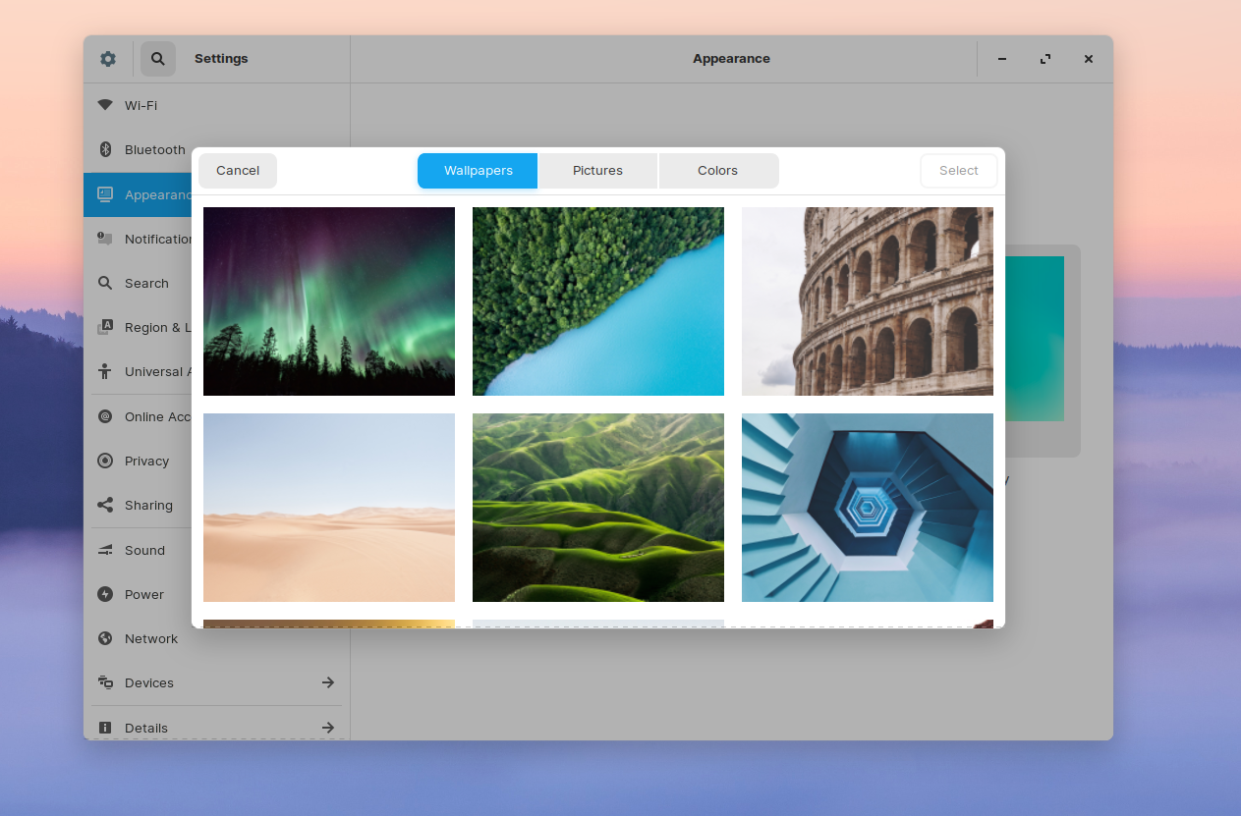

**After Changing Background**

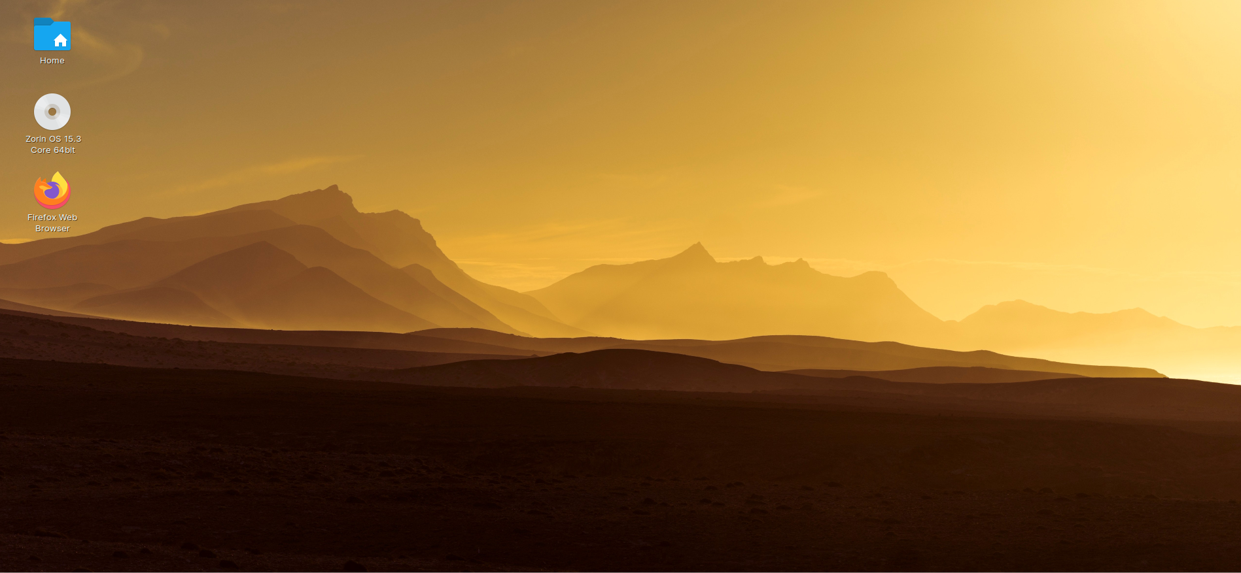

**Changing theme**

**Go to settings and click on ‘Appearance’, click on the option zorin appearance.**

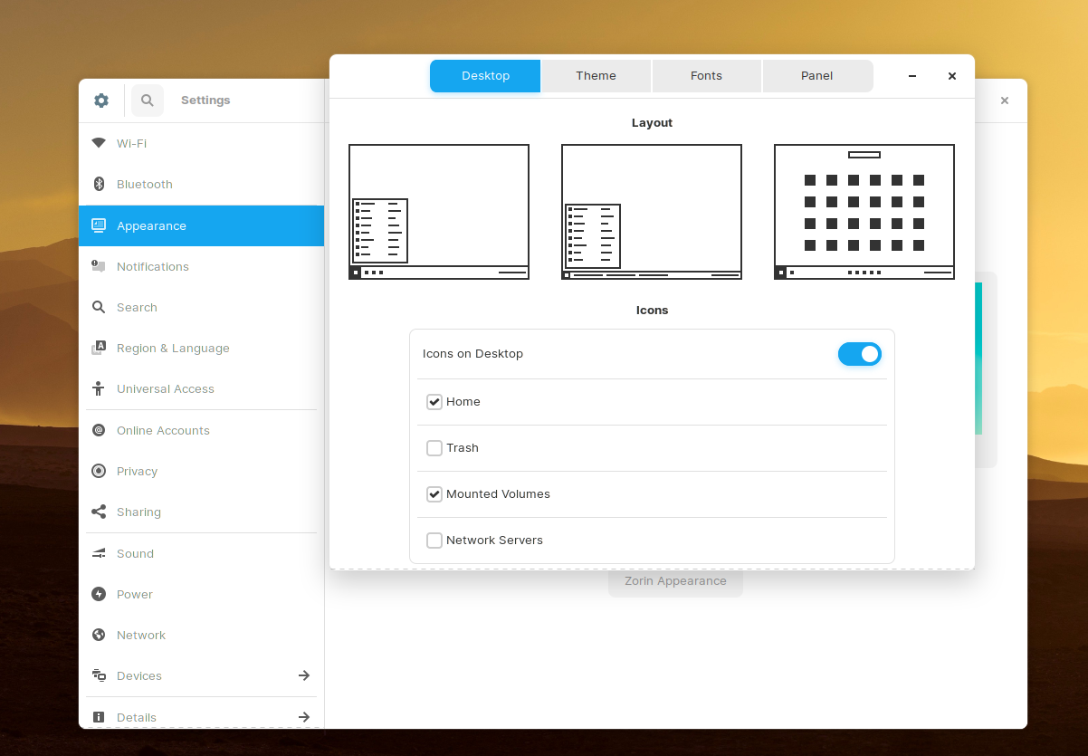

**Select the option theme and pick the theme you wanted.**

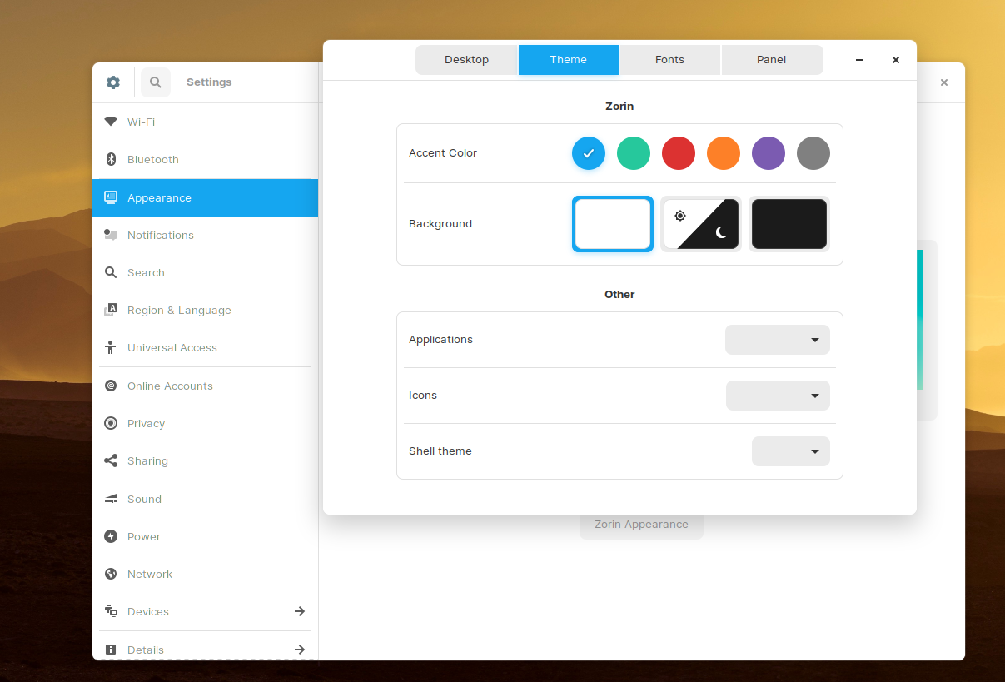

**After Changing the theme**

